**Lesson 8 Demo 2**

**Create Workloads in an AKS Cluster**



**Steps to be followed:**

1. Creating a namespace
2. Creating a pod
3. Creating a deployment

**Step** **1:** **Creating a namespace**

* 1. Inside the **SL-Cluster**, navigate to **Namespaces** under the **Kubernetes resources** section and click on the **Add** button

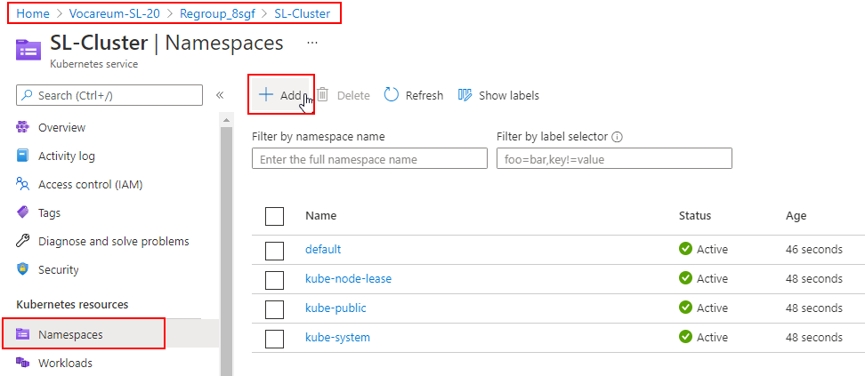

* 1. Add the following code to the **YAML** section and click on the **Add** button:

***apiVersion: v1***

***kind: Namespace***

***metadata:***

***name: first-namespace***

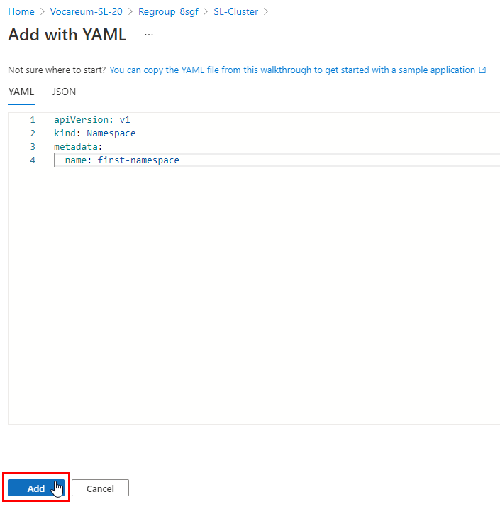

* 1. Check the newly created **first-namespace** in **Namespaces** section

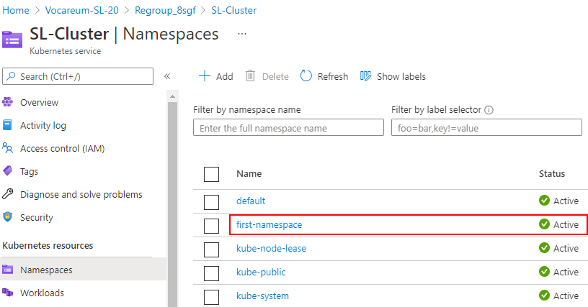

**Step 2: Creating a pod**

1. Inside the **SL-Cluster**, go to **Workloads** under the **Kubernetes resources** section, select **Pods** tab, and click on the **Add** button

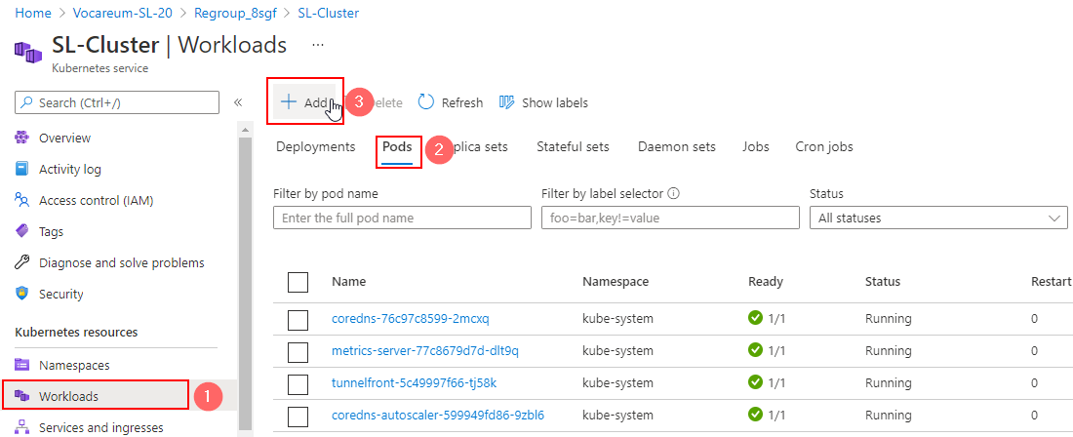

1. Add the following code to the **YAML** section and click on the **Add** button:

***apiVersion: v1***

***kind: Pod***

***metadata:***

***name: firstpod***

***namespace: first-namespace***

***spec:***

***containers:***

***- name: firstpod***

***image: busybox***

***command: ['sh', '-c', 'echo "Hello, Kubernetes!" && sleep 3600']***

***restartPolicy: OnFailure***

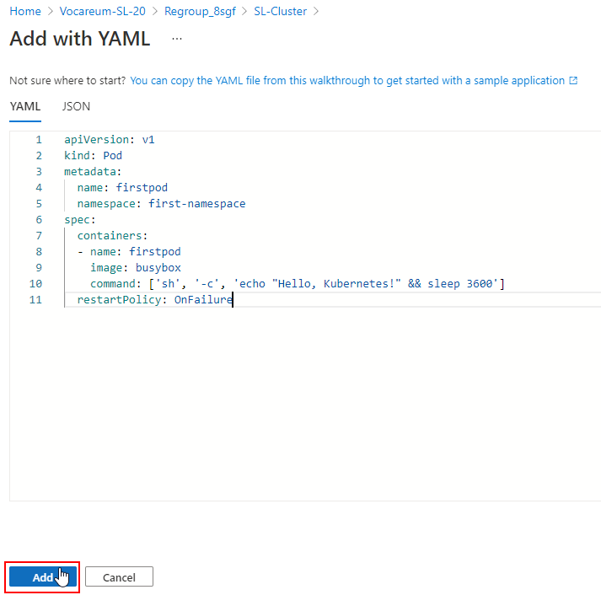

1. Check the newly created **firstpod** under the **Pods** tab

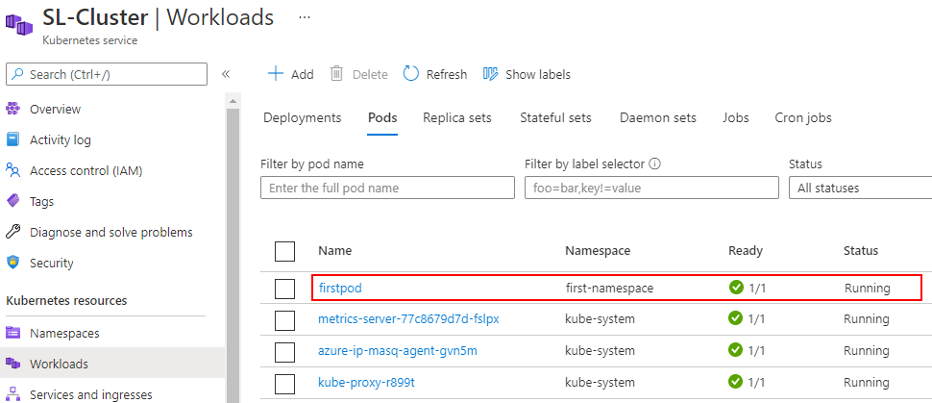

| **Note:** You can also filter the Pods by **pod name**, **label selector**, **status**,and **namespace**. |
| --- |

**Step 3: Creating a deployment**

1. Inside the **SL-Cluster**, go to **Workloads** under the **Kubernetes resources** section, select **Deployments** tab, and click on the **Add** button

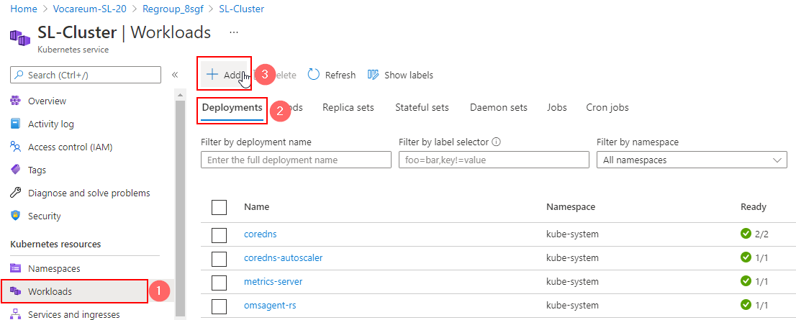

1. Add the following code to the **YAML** section and click on the **Add** button:

***apiVersion: apps/v1***

***kind: Deployment***

***metadata:***

***name: first-deployment***

***namespace: first-namespace***

***labels:***

***app: first-deployment***

***spec:***

***replicas: 3***

***selector:***

***matchLabels:***

***app: first-deployment***

***template:***

***metadata:***

***labels:***

***app: first-deployment***

***spec:***

***containers:***

***- name: first-deployment***

***image: nginx:1.14.2***

***ports:***

***- containerPort: 80***

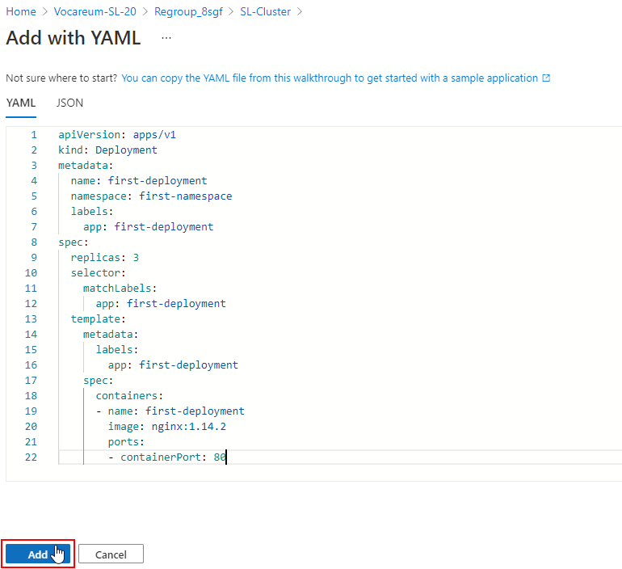

1. Check the newly created **first-deployment** under the **Deployments** tab

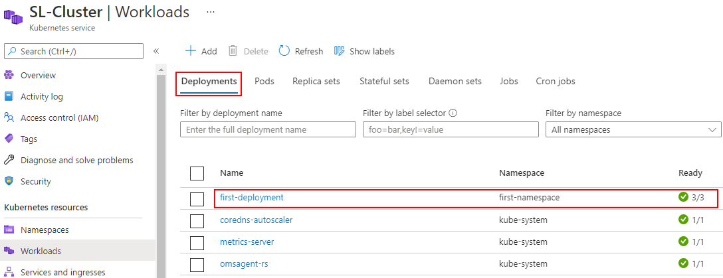

| **Note:** You can also filter the Deployments by **deployment name**, **label selector**,and **namespace**. |
| --- |

1. Go to the **Pods** tab again to check the running pods created by the **first-deployment**

